4-H Online 2.0 Animal Entry Guide
Horse Project
*Note: For 4-H Members 8 and above

Log into 4-H Online

- Use your family email and password co.4honline.com

Click “View”, next to Member’s Name

Locating ‘Animals’
- Desktop, select “Animals” from the left side navigation

- Smart Phone or Tablet, click on the 3 bars in the top left corner
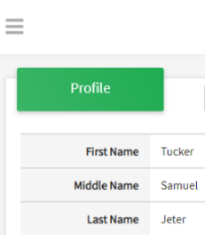
With either option, this will bring up a drop down list to begin adding Animals.

Adding an Animal
- Click "Add an Animal"
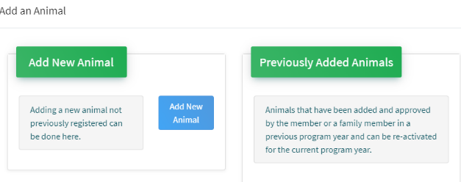Then select “Add New Animal”
- Select Horse, from the drop down. REQUIRED: Enter Animal’s name, click “Save”
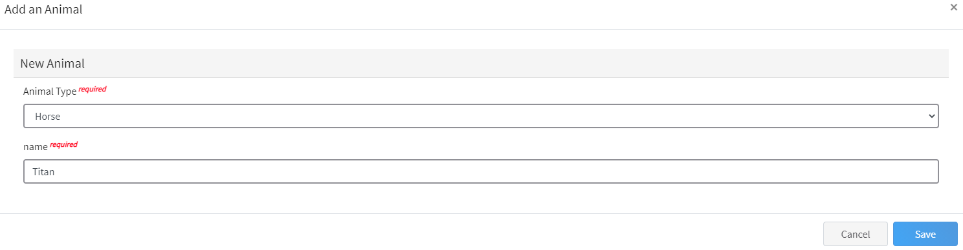
- Next, click “Show Questions”
Animal Entry is open for the current enrollment year. - Is all information complete? Check all county animal entry deadlines.
READ All County instructions for each animal species as county requirements vary.
- The animal’s name will be carried over from the previous screen. This would be the Animal Common Name or Barn Name
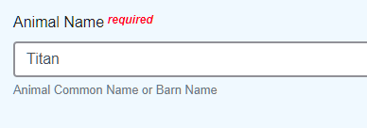
- Enter the animal’s birth date.
- Choose the breed from the drop-down box. Choose “other breed” or “mixed breed” if breed isn’t listed. ONLY select one breed.

- Fill in a description of the horses’ colors and markings.
- Enter the horses’ height in inches as measured from the ground to withers (highest point of the horses’ shoulders).
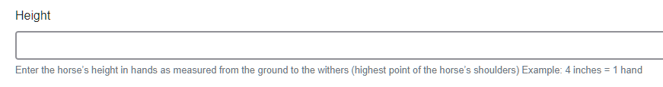
- Enter Premises or Location ID, if applicable in your county.
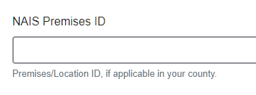
- Enter whether you own or lease the horse.

- Enter the registered name if your horse is registered.
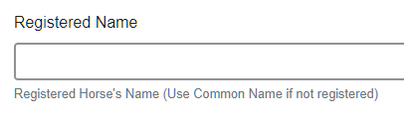

- Enter the Animal Gender – male or female.

- Enter Tattoo or Brand, if applicable
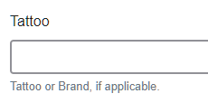

- Click “Next”, continue with the “File Uploads” that are required by your local county extension office. These will vary by county and species. Please follow all your county guidelines.

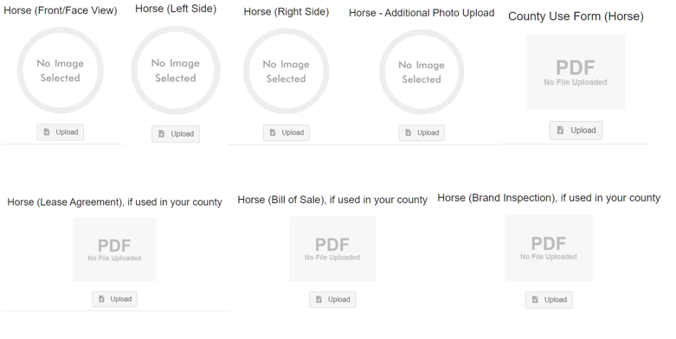

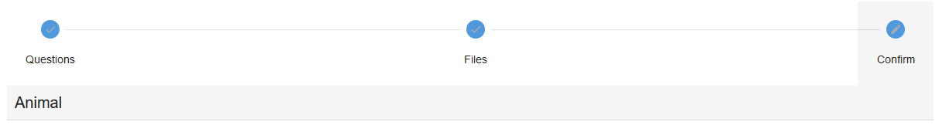
- Confirm all information, click ‘submit’
- County Extention staff, will review all information. If more is needed, members can edit. Once “Approved” by your local county extension office an email will be sent to your family account (example below) A time and date stamp for each animal.
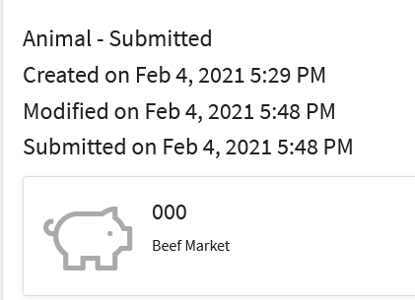
Questions, please contact your local extension staff.

